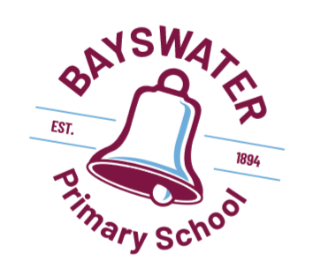

Dress Code Policy 2022

Aims and Aspirations
The Bayswater Primary School Dress Code Policy is developed and approved by the Bayswater Primary School Board.
A school uniform helps to create a sense of identity among students and assists with building the school community and team spirit. A dress code has many benefits, including:
- Encouraging equity among students.
- Ensuring that students are safely dressed for specific school activities.
- Preparing students for future life skills in the community and workplace.
- Providing a method of easy identification of students and contributing to a safe environment.
- Offering an economical form of school attire.
- Fostering and enhancing the public image of the school.

School Uniform
The Dress Code Policy requires students to wear appropriate uniform items in the school colours: maroon and aqua blue. Uniforms can be purchased from Nell Grey Uniform Concepts. All students are required to purchase the correct uniform polo shirt and jacket. Other uniform items can be purchased from other suppliers for a more affordable option, as long as they are in correct colours. All coats, parkas and non school jackets where possible should be maroon in colour and should be removed before going into class.
Uniform Items
Tops Bottoms
- Polo shirt (School shirt)  - Faction polo (in faction colour)  - Summer dress (Maroon check)  - Windcheater (Maroon)  - Zip up Jacket (School jacket)  - Wide brimmed/bucket hat (Maroon)  - Leaders shirt (Year 6 students)  - Leaders Jacket (Year 6 students) | - Shorts (Maroon)  - Pleated skirt (Maroon)  - Sports skirt/Skort (Maroon)  - Track pants (Maroon)  - Cargo trousers (Maroon)

Footwear
Fully enclosed, flat soled shoes are to be worn as part of the Dress Code Policy. This ensures that basic safety and health issues are addressed. Students participate in physical activities most days of the week so sports shoes are recommended everyday as well as being a requirement for all sports events. Sandals are acceptable in summer as long as they do not compromise safety.
- No thongs, reefs or backless sandals are allowed.
- Socks should be in plain colours

Hats
Bayswater Primary School is a SunSmart school and has a “No Hat – No Play” approach for the four terms of the year.
- The wearing of hats for outdoor activities, including recess and lunch times is compulsory, for health and safety reasons.
- Hats must be broad brimmed or legionnaire style. Baseball/peaked caps do not provide adequate protection and are not permitted.

Further information is available in the School’s SunSmart Policy.

Hair, Jewellery and Make-up
Students with shoulder-length or longer hair should tie their hair back.
Excessive jewellery is not appropriate for safety reasons - Stud and sleeper earrings are acceptable. Makeup is not appropriate.

Expectations
All students are expected to be in full school uniform at all times. Staff will encourage correct attire and communicate this regularly to the school community. The following strategies will be used to encourage compliance with the Dress Code Policy:
- Students may be asked by staff to explain why they are not in school uniform.
- The school may initiate incentive strategies to reward students in correct uniform
- Staff may contact parents to discuss the requirements of the Dress Code Policy.
- Students may be offered spare uniforms to wear.
- Students not in school uniform will be unable to attend excursions.
The Principal, on behalf of the School Board will issue exemptions. Grounds for an exemption include:
- Exemptions for religious reasons.
- Exemptions relating to cultural background.
- Exemptions for health reasons.
- Exemptions for financial reasons

Parents are requested to seek approval for Dress Code exemptions in writing to the Principal.

Endorsed by School Board 7 September 2022

